**Ex. No.: 7 Date:**

# **MITM ATTACK WITH ETTERCAP**

**Aim:**

To initiate a MITM attack using ICMP redirect with Ettercap tool.

# **Algorithm:**

1. Install ettercap if not done already using the command- dnf install ettercap
2. Open etter.conf file and change the values of ec_uid and ec_gid to zero from default. vi /etc/ettercap/etter.conf
3. Next start ettercap in GTK ettercap -G
4. Click sniff, followed by unified sniffing.
5. Select the interface connected to the network.
6. Next ettercap should load into attack mode by clicking Hosts followed by Scan for Hosts
7. Click Host List and choose the IP address for ICMP redirect
8. Now all traffic to that particular IP address is redirected to some other IP address.
9. Click MITM and followed by Stop to close the attack.

# **Output:**

[root@localhost security lab]#dnf install ettercap [root@localhost security lab]# vi /etc/ettercap/etter.conf [root@localhost security lab]# ettercap –G

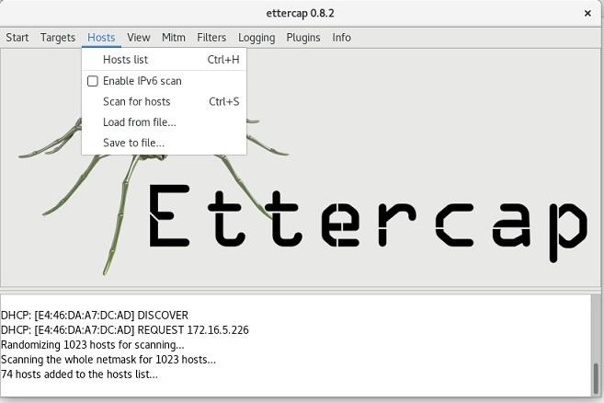

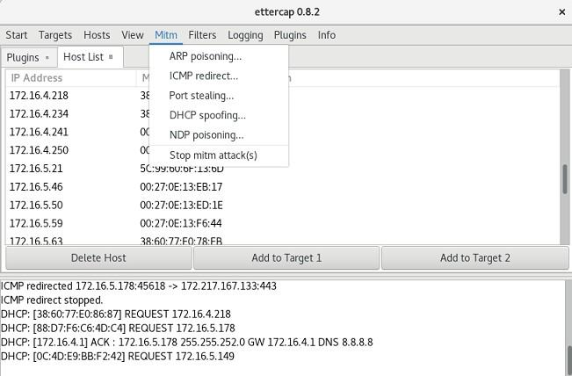

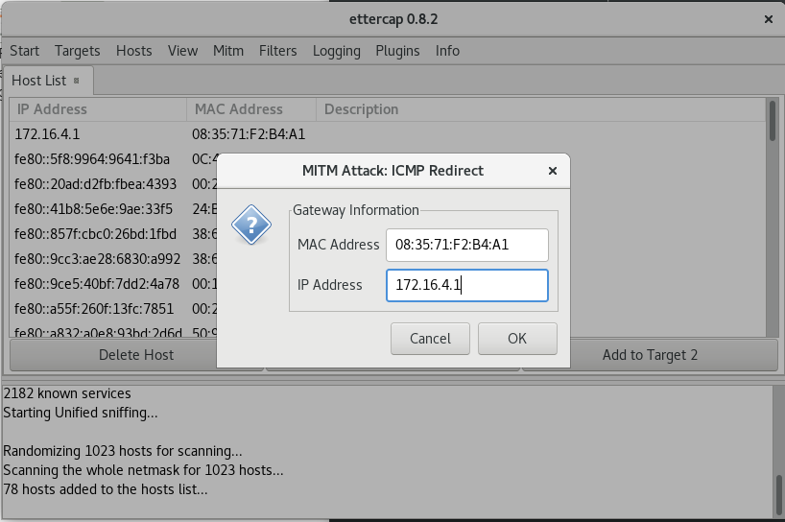

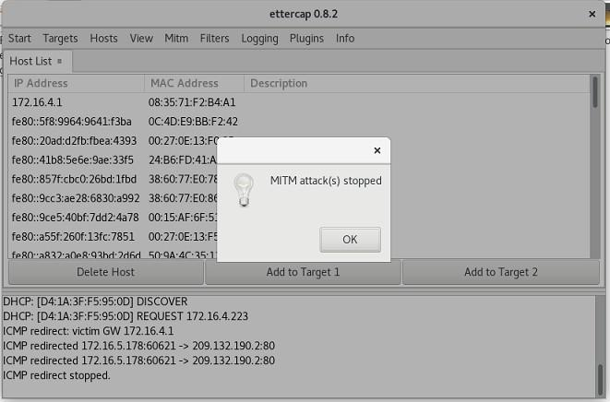

Ettecap tool:

Ettercap is a well-known open-source tool used for conducting man-in-the-middle attacks on a local area network (LAN). It essentially functions as a network eavesdropper, allowing you to intercept traffic flowing between devices on the network.

* **Man-in-the-Middle Attacks:** By manipulating ARP (Address Resolution Protocol) Ettercap can position itself as an intermediary between two communicating devices. This allows it to intercept and potentially alter data flowing between them.

Ettercap's capabilities:

* **Packet Sniffing:** Ettercap can put your network interface in promiscuous mode, enabling it to capture all network traffic on the LAN segment, not just traffic directed to your device.
* **Man-in-the-Middle Attacks:** By manipulating ARP (Address Resolution Protocol) Ettercap can position itself as an intermediary between two communicating devices. This allows it to intercept and potentially alter data flowing between them.
* **Protocol Analysis:** Ettercap can dissect and analyze various network protocols, including some encrypted ones. This provides valuable insights into network communication patterns.
* **Data Injection and Filtering:** Ettercap can inject data packets into ongoing connections or filter out unwanted packets, enabling activities like modifying data streams.
* **Multiple Sniffing Modes:** Ettercap offers various sniffing modes, like IP-based, MAC-based, and ARP-based, catering to different network scenarios.

It's important to remember that Ettercap is a powerful tool and should be used with caution. While it's valuable for ethical hackers and penetration testers to assess network security, using it for malicious purposes is illegal.

* Ettercap offers both a graphical user interface (GUI) and a command-line interface (CLI) for user convenience.
* Ettercap has plugin support, allowing you to extend its functionalities.